Liberty & Wilderness
William O. Douglas Film Project
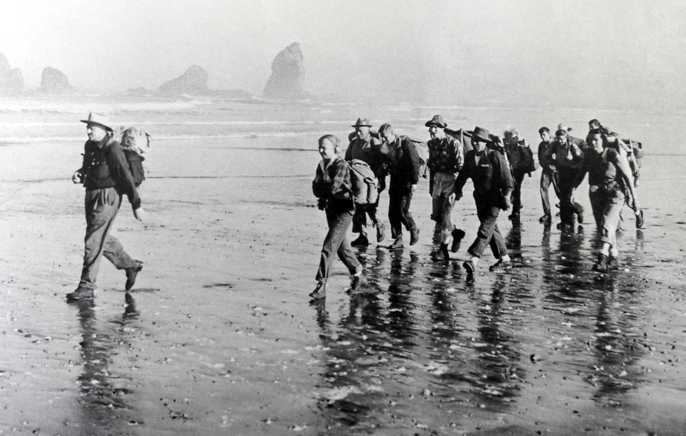
William O Douglas leads a hike protesting a proposed coastal highway at Pacific Beach,Washington. 1958
Photo by Ira Spring , Courtesy of Olympic Park Institute

William O. Douglas was a beacon for the preservation of wild places and individual freedom, by word and by example. These were parallel rights to be defended without reservation.
Douglas described the wilderness not merely as an escape, but as a nurturing environment and source of strength, an affirmation of independence that empowers individuals and offers spiritual and physical salvation.
He was a guardian against any boundary that restrained liberty and any new control that threatened individual freedom. The answer to society’s problems is more freedom, not less. This was the message he gave in countless speeches to citizens, not just the legal and academic world.
As a sitting Supreme Court Justice, no one in the nation brought such a high profile to these issues. His life stands as a record of courage to hold fast against the forces that would exploit or erode these precious American ideals.

williamodouglas.org

Two exhaustive biographies have been written about Douglas totaling twelve-hundred pages of text. Unfortunately, only a few dozen of these pages are devoted exclusively to his legal and personal relationship with the natural world.
“He was our greatest environmental jurist. He had a very, very close relationship with my family. There is nobody in American history that I more admire than him. What he understood, which is what I think more and more people are understanding, is that protecting the environment is not about protecting the fishes and the birds for their own sake. It's about recognizing that nature is the infrastructure of our communities, and we must meet our obligation as a generation, as a civilization, as a nation, to create communities for our children that provide them with opportunities for dignity and enrichment and good health.”
Robert F. Kennedy, Jr.
at the Sierra Summit, September 10, 2005

This is a story with a national footprint and issues that radiate far beyond U.S. borders. Douglas’ passion for nature helped to propel the modern environmental movement into mainstream consciousness. The land ethic and protection of wilderness areas have become defining issues across the planet.
Douglas often used a metaphor of the natural world to underpin the rights of individuals. These rights were not self-implementing, he said, and his words implored people to be ever vigilant.
“As nightfall does not come all at once, neither does oppression. In both instances there is twilight where everything remains seemingly unchanged. And it is in such twilight that we must be aware of change in the air - however slight - lest we become unwitting victims of the darkness.”
Letter, William O. Douglas
Washington State Bar Association, 1976

Liberty & Wilderness on YouTube

http://www.youtube.com/watch?v=BXBoScDnDr4

A Production of the Oregon Cultural Heritage Commission



The Oregon Cultural Heritage Commission is a 501(c) (3) not-for-profit educational organization.

All donations are tax deductable.

