
2013 OUTSTANDING ACHIEVEMENT AWARDS
call for nominations

12th Annual Crime Victim Law Conference | June 7-8, 2013 | Portland, Oregon
Award Submission Deadline: Friday, November 30, 2012

The National Crime Victim Law Institute (NCVLI) invites you to nominate individuals and/or organizations to receive a 2013 Outstanding Achievement Award. These awards recognize individuals and/or organizations in one of three categories listed at the bottom of this page. NCVLI presents the awards at its annual Crime Victim Law Conference.

PURPOSE

To recognize attorneys, advocates, and organizations that have made significant contributions to the enhancement of crime victims’ status and standing within the criminal justice system.

ELIGIBILITY GUIDELINES

- The award recipient must be an attorney, advocate, or organization that has demonstrated dedication, leadership, and outstanding achievement in assisting crime victims, enforcing crime victims’ rights, and working as a catalyst for positive change in the criminal justice system.

- Candidates nominated but not selected in previous years are also eligible for consideration. Previous award winners are not eligible. For information on past recipients visit the Conference webpage at www.ncvli.org.

NOMINATION SUBMISSION GUIDELINES

- You may nominate an individual, an organization, or a team of individuals or organizations in any of the three categories.

- The description of the nominee’s accomplishments should not exceed 500 words and should make clear the nature and significance of the achievement and the nominee’s specific role in that achievement.

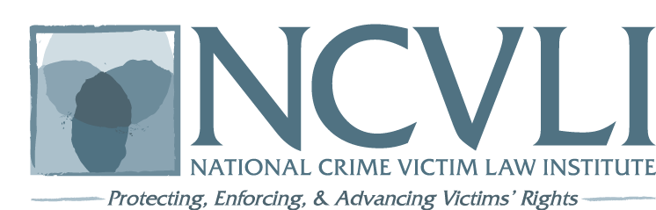
- You may submit supporting materials, such as a biography or resumé that summarizes the nominee’s background and experience. If the nominee is an organization, describe its mission and objectives and provide a brief history of the organization.

- Please complete a separate nomination form for each individual, organization, or team nominated.

SELECTION PROCESS

NCVLI’s award committee reviews the nominations and selects the award recipients.

TERMS OF THE AWARD

Acceptance of an award authorizes NCVLI to publish the award recipient’s names, photos, and/or profiles on its website and in promotional materials.

Mail, fax, or email completed nomination form to:

National Crime Victim Law Institute
Attn: Awards
310 SW 4th Avenue., Suite 540, Portland, OR 97204
e. ncvliconference@lclark.edu f. 866-301-8794

2013 Outstanding Achievement Award Categories – visit the Conference webpage or www.ncvli.org to learn more

Gail Burns-Smith Excellence in Victim Services

This award recognizes outstanding efforts of an advocate, attorney, or allied professional in advancing the rights of crime victims and shedding light on often hidden issues.

VICTIMS’ RIGHTS PARTNERSHIP AWARD

This award recognizes the collaborative efforts of individuals and/or organizations who have devoted their time to advancing crime victims’ rights.

LEGAL ADVOCACY AWARD

This award recognizes crime victims’ rights attorneys who have dedicated and committed their time to representing victims of crime in the criminal justice system.

Nominator Information -----------------------------------------------------------------------------------------------------------------------------------------------------------------------------
Name:
Title or Position:
Organization:
Mailing Address:
City: |  |  |  |  |  |  | State: |  | Zip Code:
Telephone Number: |  |  |  |  |  | Fax Number:
Email:

Nominee Information -----------------------------------------------------------------------------------------------------------------------------------------------------------------------------------

Type of Award (check only one)
Legal Advocacy Award
Gail Burns-Smith Excellence in Victim Services Award
Victims’ Rights Partnership Award

Name:
Title or Position:
Organization:
Mailing Address:
City: |  |  |  |  |  |  | State: |  | Zip Code:
Telephone Number: |  |  |  |  |  | Fax Number:
Email:
If you are nominating an organization, please provide the name(s) of the individual(s) who would accept the award on behalf of the organization or program.
Nominee’s Full Name:

service/accomplishments ------------------------------------------------------------------------------------------------------------------------------------------------------------------------

In 500 words or less, summarize the nominee’s accomplishments and your reason for nominating this individual, organization, or team. You may include this on a separate sheet of paper. If you are nominating an individual for the Gail Burns-Smith Excellence in Victim Services Award, specifically address how the nominee exemplifies Gail’s leadership in advancing the rights of crime victims and her tireless advocacy to shed light on often hidden issues. For information about Gail, please refer to information about the Outstanding Achievement Awards on the Conference webpage or www.ncvli.org.

