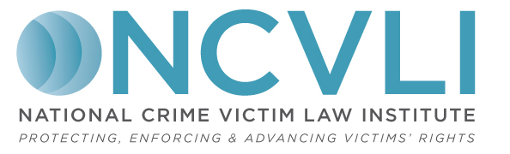


Crime Victim Law Conference
Law Student Scholarship

Thanks to funding made available from a generous donor, NCVLI is pleased to offer a full tuition scholarship to an eligible law student to attend the 2018 Crime Victim Law Conference. The Scholarship is designed to support the growth of victim law learning, scholarship, and advocacy by law students who attend schools other than Lewis & Clark Law School in Portland, Oregon where NCVLI is based.

Eligibility: Eligible individuals are:
- enrolled in an ABA accredited law school or matriculated from such school within the past twelve (12) months;
- have a demonstrated interest in helping victims of crime; and
- attend or have matriculated from a law school other than Lewis & Clark Law School in Portland, Oregon.

What is Available: Funding is available to cover tuition (which includes light refreshments on both days; attendance at all conference sessions; and all conference materials). Funding is not available for travel costs or hotel expenses.

Procedures and Deadline: Please complete the following form in its entirety and submit to NCVLI no later than February 16, 2018. Send completed forms to:

- Mail: NCVLI, 1130 SW Morrison St, Ste 200, Portland, OR 97205
- Email: ncvliconference@lclark.edu

Additional Information about the Conference: The National Crime Victim Law Institute’s annual Crime Victim Law is the only national conference focusing on Victim Law, including rights enforcement in criminal cases. The audience of the Conference is a growing community of attorneys, advocates, allied professionals, law students, professors, and victims/survivors. Attendees will learn the practical skills necessary to serve victims and participate in key conversations that will shape the future of victims’ rights. The Conference will feature plenary sessions and breakout sessions addressing topics of critical importance to the victims’ rights community, taught by leading experts from across the country.

Law Student Scholarship Application Form

Name:
Law School:
Year of Graduation:
Mailing Address:
City: |  |  | State: |  | Zip Code:
Telephone Number: |  | Fax Number:
Email:
Please limit your responses to the following questions to no more than 100 words per question.

Describe your interest in victim law:

Describe how attending NCVLI’s Conference would benefit you and your professional development:

Briefly tell us why a scholarship is necessary for you to attend the Conference:

Have you attended NCVLI’s Crime Victim Law Conference previously? If so, what year(s)?

Is there anything else we should know when considering your application?



